# Exercise 6

## System 1:

$$G\left(s\right)=\frac{1}{s^{2}+10s+20}$$

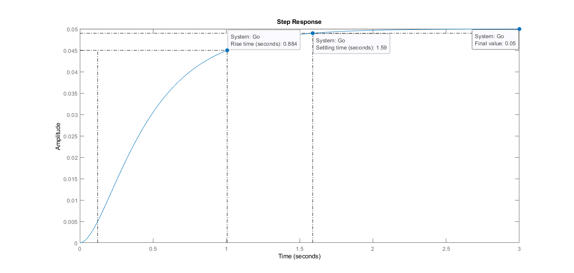

Figure 1. Step Response for Open Loop System without any Controller

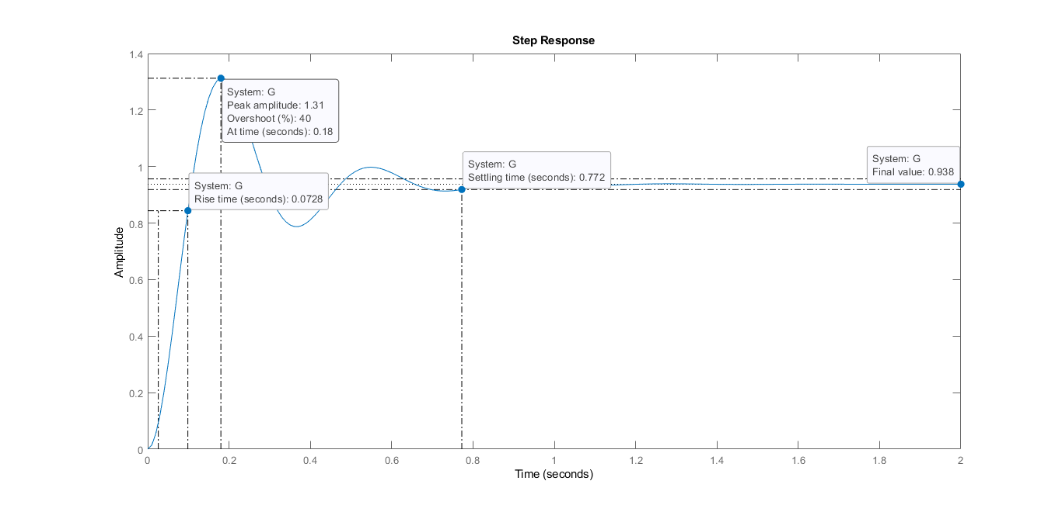

Figure 2. Step Response with P-Controller

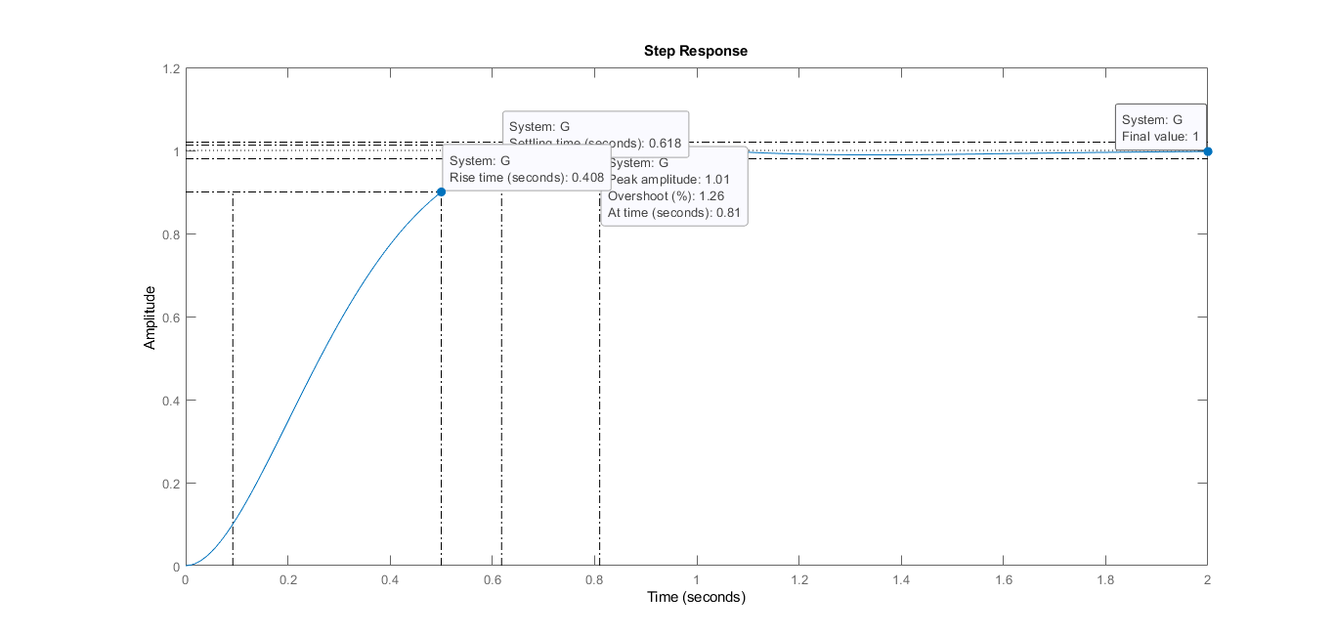

Figure 3. Step Response with PI-Controller

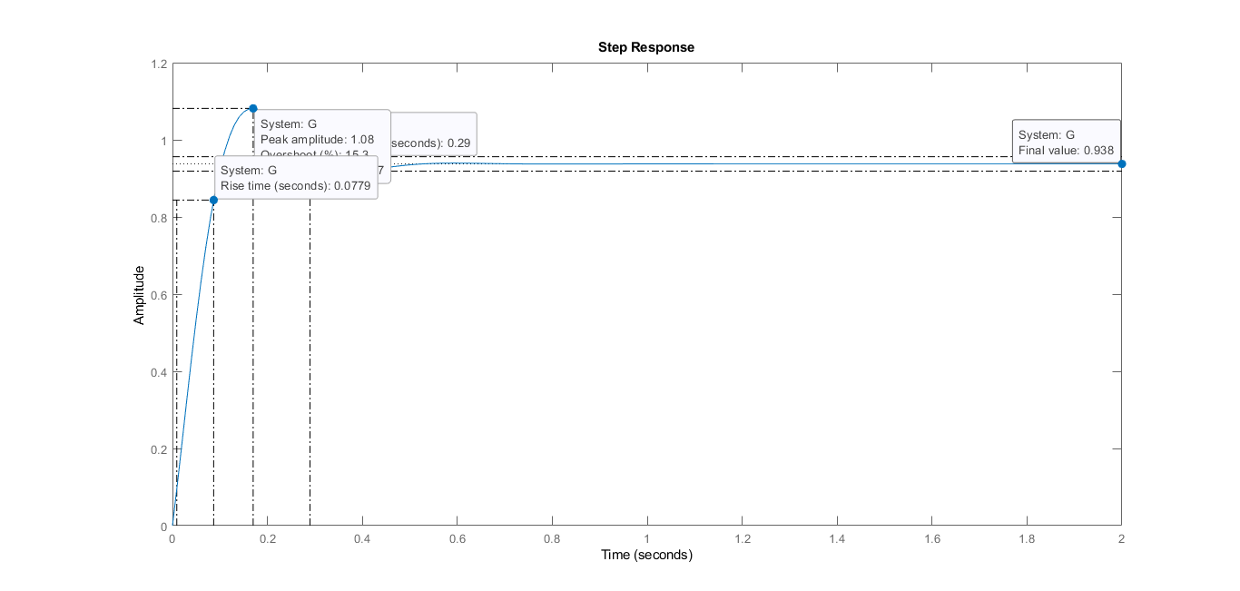

Figure 4. Step Response with PD-Controller

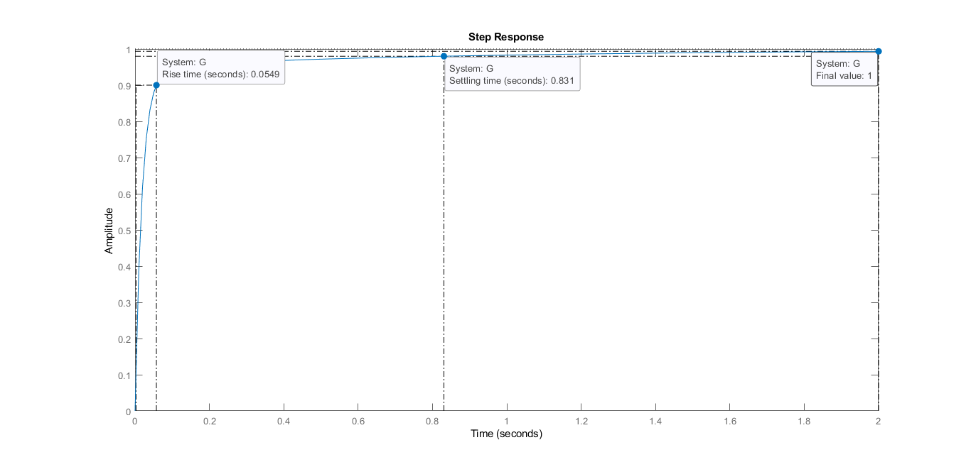

Figure 5. Step Response with PID-Controller

**Controller Performance Metrics:**

|  |  |  |  |  |
| --- | --- | --- | --- | --- |
| **Controller** | **Rise Time (s)** | **Overshoot (%)** | **Settling Time (s)** | **Steady-State Error** |
| P | 0.0728 | 40.0 | 0.772 | 0.062 |
| PI | 0.4080 | 1.26 | 0.618 | 0.000 |
| PD | 0.0779 | 15.3 | 0.290 | 0.062 |
| PID | 0.0549 | - | 0.831 | 0.000 |

## System 2:

$$G\left(s\right)=\frac{100}{(s+1)(s+2)(s+10)}$$

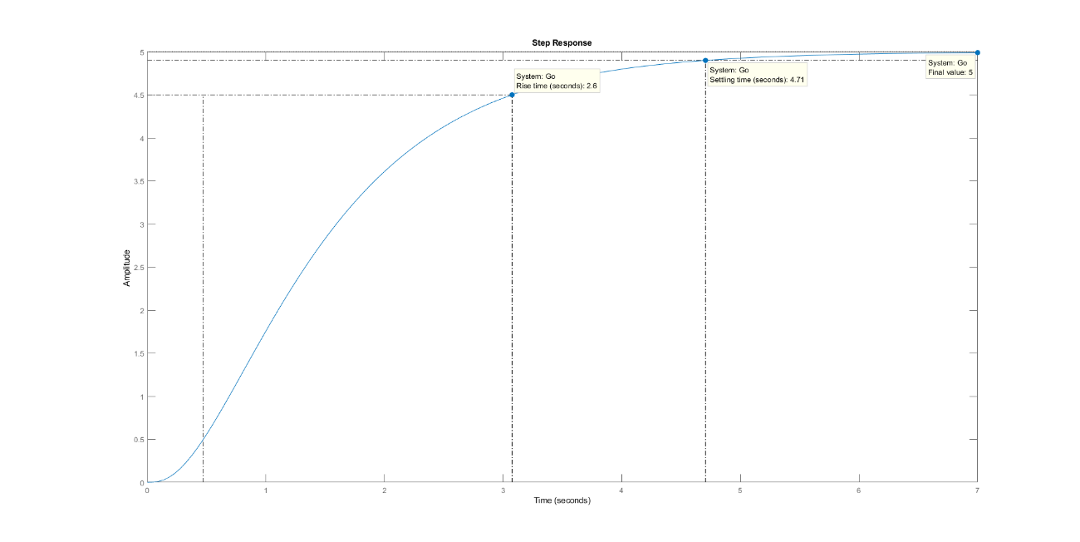

Figure 6. Step Response for Open Loop System without any Controller

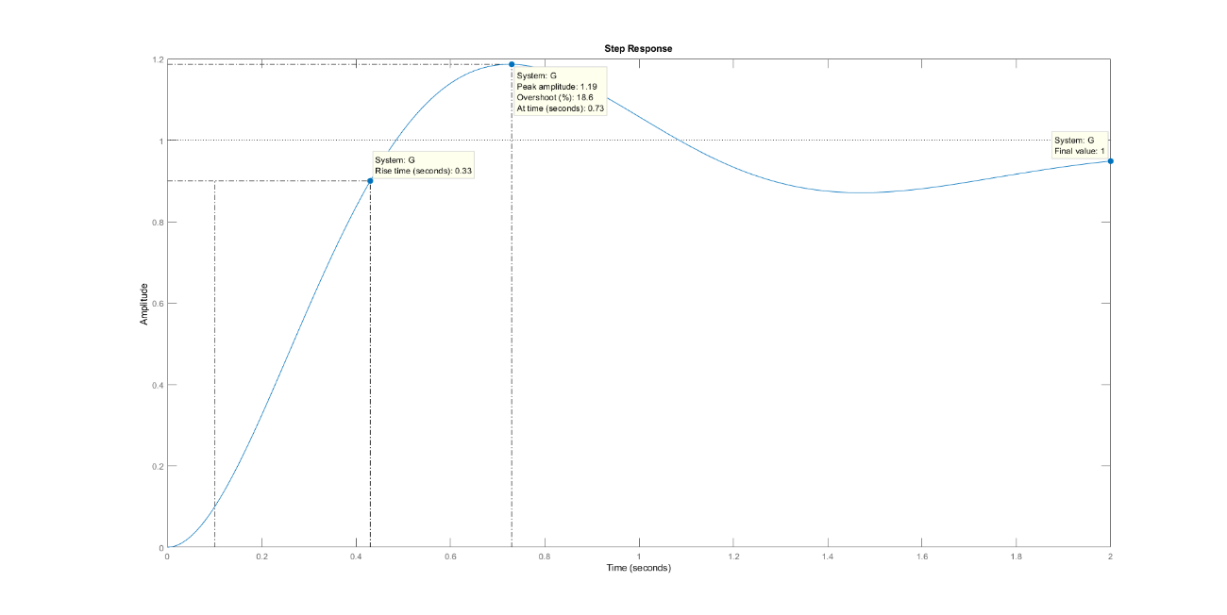

Figure 7. Step Response with PID-Controller